**SQL Lab 9/9/2021**

Here you will connect to a database that lives in the cloud. Once you connect, you will use MySQL to write sql queries to answer questions.

For each question include a file with the sql statement separated by a “;”

Name your file

***Lastname.firstname.9-9-lab.sql***

Upload it to Collab in the file drop. You can turn this in by Monday at 6:00PM

**Connecting to MySQL Instance in the cloud (in this case, Digital Ocean)**

1. **Open up your MySQL SQL Workbench**
2. **Click the little Plus Sign next to MySQL CONNECTION**
3. **You will see this screen**

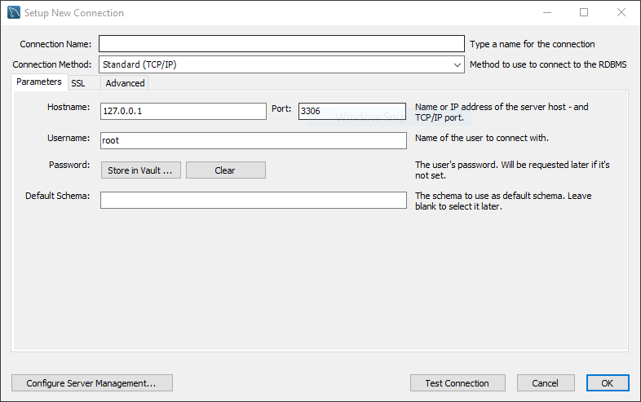

1. **Add a Connection name – like DS3002 (do whatever you want)**

**In the Hostname field – type the following server name**ds3002-do-user-2852131-0.b.db.ondigitalocean.com

**Use the Port: 25060**

1. **The user name is: student**
2. **Click Okay and use “mz3NJZzgY-XuqIzu” as the password. It’s okay to save that in your keychain(mac) or Valut (windows)**
3. **For the Default Schema enter “mynorthwind”**

**It should look like this:**



**You should be in!**

**Product Table Queries:**

**1.**Write a query to get Product name and quantity/unit.

**2.**Write a query to get current Product list (Product ID and name). 

**3.**Write a query to get discontinued Product list (Product ID and name).

**4.**Write a query to get most expense and least expensive Product list (name and unit price).

**5.**Write a query to get Product list (id, name, unit price) where current products cost less than $20.

**6.**Write a query to get Product list (id, name, unit price) where products cost between $15 and $25.

**7.**Write a query to get Product list (name, unit price) of above average price.

**8.**Write a query to get Product list (name, unit price) of ten most expensive products.

**9.**Write a query to count current and discontinued products.

**10.**Write a query to get Product list (name, units on order, units in stock) of stock is less than the quantity on order.